



CelebManager

User Guide



Product of CS2103JAN2018-W14-B4

Last Updated: 7 April 2018

**Table of Contents**

|  |  |  |  |  |  |  |
| --- | --- | --- | --- | --- | --- | --- |
| **1** | Introduction……………………………………………………………………………………………………………. | | | | | *3* |
| **2** | Quick Start………………………………………………………………………………………………………………. | | | | | *4* |
| **3** | Commands.…………………..………………………………………………………………………………………... | | | | | *6* |
|  | **3.1** | General Commands……………………………………………………………………………………… | | | | *7* |
|  |  | **3.1.1** | Opening help window: help………………………………………………………….. | | | *7* |
|  |  | **3.1.2** | Clearing all entries: clear…………………………………………………………….. | | | *7* |
|  |  | **3.1.3** | Listing past commands: history………………………………………………….. | | | *7* |
|  |  | **3.1.4** | Exiting application: exit……………………………………………………………….. | | | *7* |
|  | **3.2** | Address Book Commands…………………..……………………………………………………….. | | | | *8* |
|  |  | **3.2.1** | | Adding contact: add……………………………………………………………………… | | *8* |
|  |  | **3.2.2** | | Listing all contacts: list………………………………………………………………. | | *9* |
|  |  | **3.2.3** | | Finding contact by name: find…………………………………………………….. | | *10* |
|  |  | **3.2.4** | | Deleting contact: delete……………………………………………………………… | | *11* |
|  |  | **3.2.5** | | Selecting contact: select……………………………………………………………. | | *12* |
|  |  | **3.2.6** | | Editing contact: edit…………………………………………………………………… | | *13* |
|  |  | **3.2.7** | | Removing tag: removeTag……………………………………………………………. | | *14* |
|  |  | **3.2.8** | | Undoing previous commands: undo……………………………………………... | | *15* |
|  |  | **3.2.9** | | Redoing undone commands: redo……………………………………………….. | | *16* |
|  | **3.3** | Appointment Commands…………………………………………………………………………….. | | | | *17* |
|  |  | **3.3.1** | | Adding appointment: addAppointment……………………………………….. | | *17* |
|  |  | **3.3.2** | | Listing all appointments: listAppointment………………………………… | | *19* |
|  |  | **3.3.3** | | Editing appointment: editAppointment……………………………………… | | *21* |
|  |  | **3.3.4** | | Deleting appointment: deleteAppointment……………………………….. | | *21* |
|  |  | **3.3.5** | | Viewing appointment: viewAppointment……………………………………. | | *22* |
|  | **3.4** | Calendar Commands……………………………………………………………………………………. | | | | *24* |
|  |  | **3.4.1** | | | Viewing celebrity’s calendar: viewCalendar………………………………… | *24* |
|  |  | **3.4.2** | | | Viewing combined calendar: viewCombinedCalendar…………………. | *26* |
|  |  | **3.4.3** | | | Changing calendar view type: viewCalendarBy…………………………… | *27* |
|  |  | **3.4.4** | | | Viewing specific date: viewDate…………………………………………………… | *29* |
|  | **3.5** | Map Commands…………………………………………………………………………………………… | | | | *30* |
|  |  | **3.5.1** | Clicking buttons on map……….………………………………………………………. | | | *30* |
|  |  | **3.5.2** | Showing location on map: showLocation……………………………………. | | | *31* |
|  |  | **3.5.3** | Estimating route on map: estimateRoute…………………………………… | | | *32* |
| **4** | Frequently Asked Questions…………………………………………………………………………………… | | | | | *33* |
| **5** | Command Summary……………………………………………………………………………………………….. | | | | | *34* |

1 Introduction

Thank you for using CelebManager!

CelebManager is a computer application designed for celebrity managers **to manage their celebrities' schedules**. It is **optimized for managers who prefer to work with keyboards to type in commands**.

This user guide provides detailed information to set up CelebManager in your computer and illustrates how to use the different commands with examples. There are five categories of commands: general, address book, appointment, calendar and map commands. Apart from general commands that control the overall status of CelebManager, each of the remaining four is responsible for interacting with one major part of the application as implied by their category names. On top of command usage explanation, some commonly asked questions are also addressed in this guide. When you are in doubt regarding the formats of any command, you can refer to the last section on command summary.

If you require a versatile application that can manage contacts, organise schedules, plan trips and send email, you are at the right place! CelebManager would be the best platform for you with its integration of an address book, calendar and visual maps. Jump to Section 2: Quick Start to get started. Enjoy!

2 Quick Start

Please follow these steps to have CelebManager quickly up and running on your computer.

1. Ensure you have Java version 1.8.0_60 or later installed in your computer. You can download the latest version of Java [here](https://java.com/en/download/).

|  |  |
| --- | --- |
| Lightbulb | It is important to install Java version 1.8.0_60 or later, as CelebManager will not work with earlier versions of Java. |

1. Download the latest CelebManager.jar [here](https://github.com/CS2103JAN2018-W14-B4/main/releases).
2. Copy the file to the folder you want to use as the home folder for CelebManager.
3. Double-click the file to launch CelebManager. Within a few seconds, you should see the interface of CelebManager similar to *Figure 1* below.

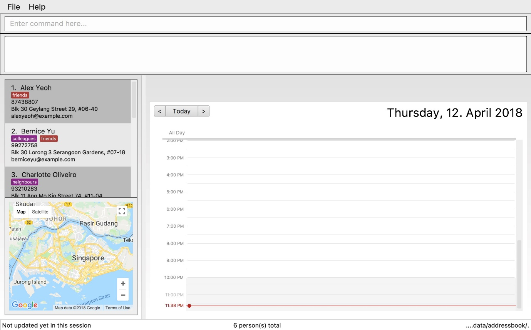

*Figure 1 Interface of CelebManager upon the first launch*

CeleManager’s interface comprises of 5 panels: CommandBox (top), ResultDisplay (right below CommandBox), PersonListPanel (middle left), MapPanel (bottom left) and CalendarPanel (bottom right), as labelled in *Figure 2* below. Note that the labelling is for illustration purpose and will not appear in the actual interface.

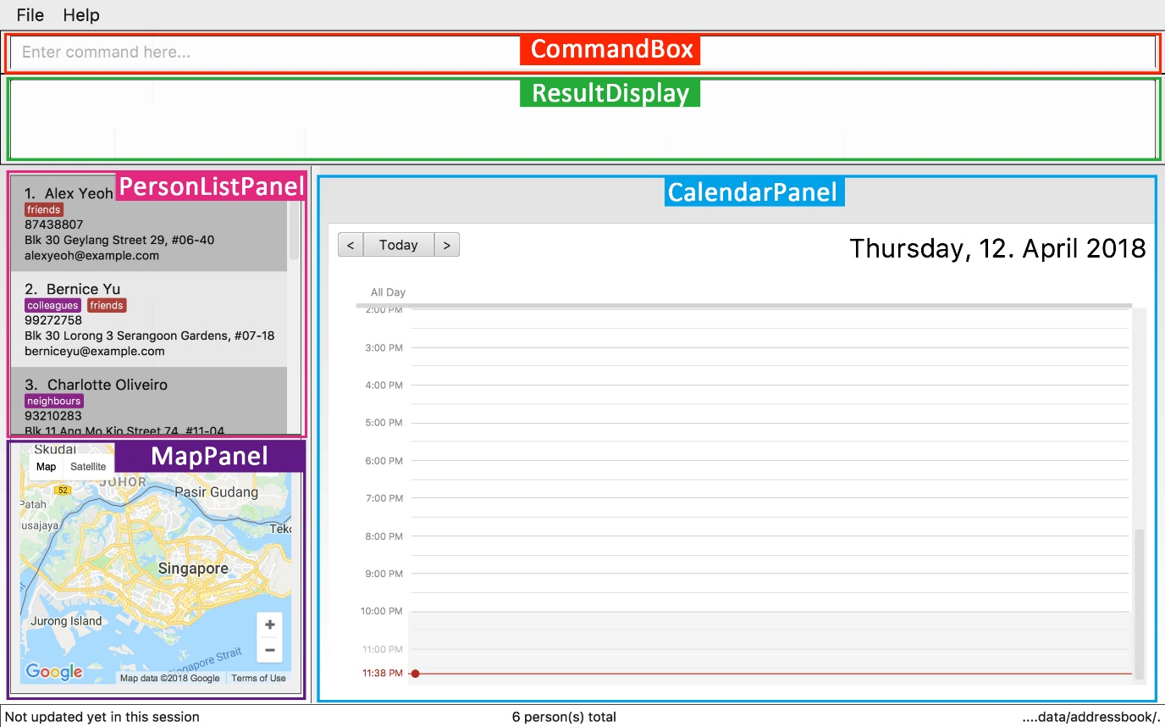

*Figure 2 Interface of CelebManager with panel labels*

1. Type help in the CommandBox and press Enter on your keyboard to execute the command. A help window should be opened.

|  |  |
| --- | --- |
| Lightbulb | CelebManager uses commands to execute tasks. All available commands are listed in Section 3: Commands. |

3 Commands

This section will introduce to you all commands available in CelebMnager.

All **commands** in CelebManager follow a general format.

* A command has a keyword that identifies itself (e.g. add, exit).
* A command may have an alias which can substitute the keyword to execute the command (e.g. the alias a can be used to substitute the keyword add).
* A command must adhere to the format given, which includes the keyword followed by parameters.

Some commands contain **parameters**, which are information entered by you for executing the command.

* Parameters are denoted in upper case, and may be prefixed with a lower case letter and a slash (e.g. n/NAME, t/TAG).
* Parameters are optional if they are denoted in square brackets in the command format (e.g. [t/TAG]).
* Parameters can be included any number of times if they are followed by … symbol (e.g. [t/TAG]… in command format implies that the command can take in any number of tags, including 0, as parameters).
* Parameters can be included in any order after the command keyword.

**3.1 General Commands**

This section details information on the general commands in CelebManager. These commands affect the overall status of CelebManger.

**3.1.1 Opening help window:** help

This command shows a help window that contains this user guide.

Format: help

**3.1.2 Cleaning all entries:** clear

**This command can result in loss of information stored in CelebManager. Please double-check before executing it.**

This command clears all saved person contacts and appointments in CelebManager.

Format: clear

Alias: c

**3.1.3 Listing past commands:** history

This command lists all the previous commands entered in reverse chronological order in ResultDisplay.

Format: history

Alias: h

|  |  |
| --- | --- |
| Lightbulb | You can navigate the previous commands by pressing the ↑ and ↓ arrows on your keyboard while you are in the command box. |

**3.1.4 Exiting application:** exit

This command exits CelebManager.

Format: exit

Alias: x

**3.2 Address Book Commands**

This section details information on the commands for the address book in CelebManager. These commands allow you to modify and interact with PersonListPanel at the middle left portion of CelebManager.

**3.2.1 Adding contact:** add

This command adds a new contact to CelebManager.

Format: add n/NAME p/PHONE_NUMBER e/EMAIL a/ADDRESS [t/TAG]…​

Alias: a

If you want to add a contact who is not a celebrity you are managing, you should not add celebrity tag.

Example:

* add n/John Doe p/98765432 e/johndoe@email.com a/123 Barkerate Street #01-01 Singapore 512123

This adds John Doe to CelebManager. PersonListPanel should be updated to

*Figure 3* below.

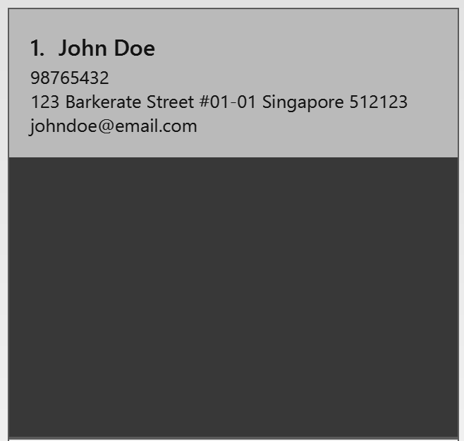

*Figure 3 State of PersonListPanel after executing add n/John Doe p/98765432 e/johndoe@email.com a/123 Barkerate Street #01-01 Singapore 512123*

If you want to add a contact who is a celebrity you are managing, you should add celebrity tag.

Example:

* add n/Jay Chou e/jay@email.com p/72048625 a/123 Taiwan #01-01 Singapore 512123 t/celebrity t/singer

This adds Jay Chou to CelebManager. PersonListPanel should be updated to

*Figure 4* below.

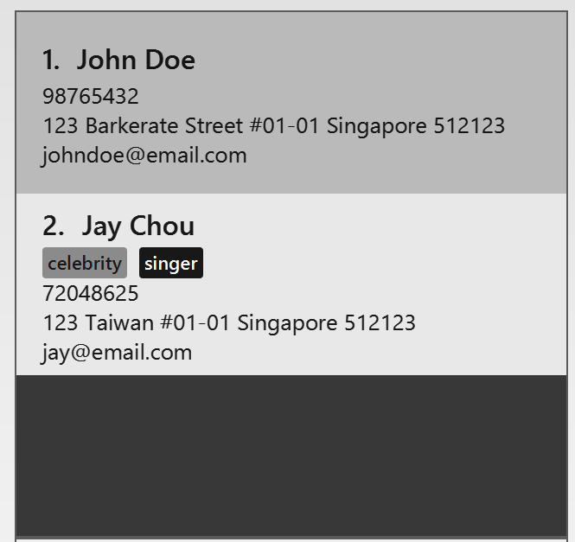

*Figure 4 State of PersonListPanel after executing* add n/Jay Chou e/jay@email.com p/72048625 a/123 Taiwan #01-01 Singapore 512123 t/celebrity t/singer

**3.2.2 Listing all contacts:** list

This command shows a list of all the contacts you have saved in CelebManager in PersonListPanel.

Format: list

Alias: l

**3.2.3 Finding contact by name:** find

This command shows a list of all the contacts whose names contain any of the given name keywords in PersonListPanel.

Format: find KEYWORD [MORE_KEYWORDS]…

Alias: f

* The match of keyword(s) is case-insensitive and the order of the KEYWORD does not matter.

e.g. The list generated after finding using Tim James will be the same as the list generated after finding using james tim.

* Only full words will be matched.

e.g. The list generated after using Tim will not have a contact with the name Timothy.

Example:

* find john

This lists out contacts whose names contain john in PersonListPanel.

If you have followed the examples for adding contacts in previous part, PersonListPanel should look like *Figure 5* on the left below before executing find john. Out of the two contacts in CelebManager, only one contact’s name contains john. As such, only this contact gets listed after executing find john as shown in *Figure 6* on the right below.

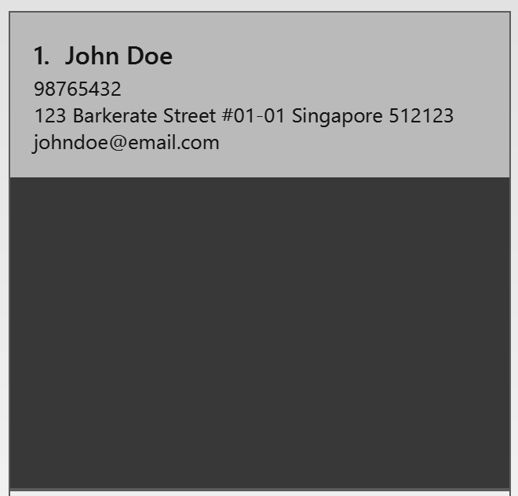

*Figure 5 State of PersonListPanel before executing find john*

*Figure 6 State of PersonListPanel after executing find john*

**3.2.4 Deleting contact:** delete

**This command can result in loss of information stored in CelebManager. Please double-check before executing it.**

This command deletes a contact specified by the index in the most recent contact listing in PersonListPanel.

Format: delete INDEX

Alias: d

Example:

* list

delete 2

This deletes the second person from the list of contacts in PersonListPanel.

If you have followed the examples to add and find contacts in previous parts, PersonListPanel should look like *Figure 7* on the left below after executing list. The second contact is Jay Chou and hence he will be deleted after executing delete 2, leaving only John Doe in PersonListPanel as shown in *Figure 8* on the right below.



*Figure 7 State of PersonListPanel*

*after executing list*

*Figure 8 State of PersonListPanel after executing delete 2*

**3.2.5 Selecting contact:** select

This command selects the contact specified by the index in the most recent contact listing in PersonListPanel.

Format: select INDEX

Alias: s

Example:

* select 1

This selects the first person from the list of contacts in PersonListPanel.

If you have followed the examples to add, find and delete contacts in previous parts, PersonListPanel should look like *Figure 9* on the left below before executing select 1. From *Figure* 9, John Doe is the first person in PersonListPanel. Hence he gets selected after exeucting select 1, as shown in *Figure 10* on the right below. Note John Doe’s information box changes colour after the execution.

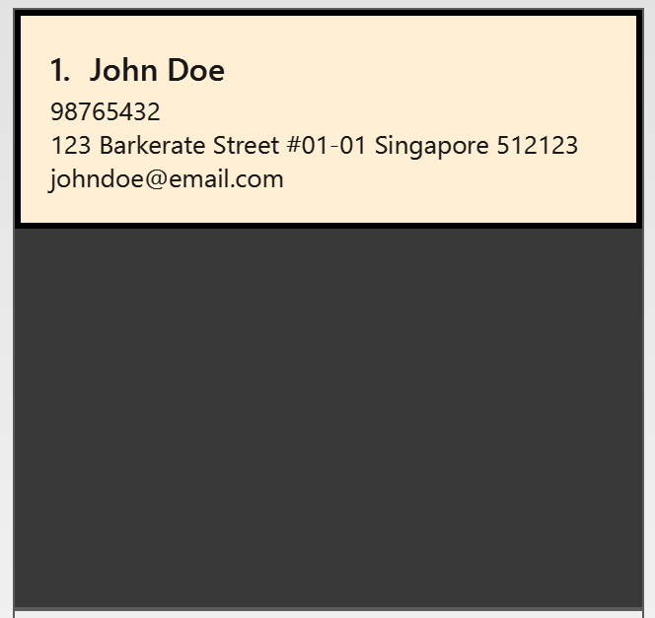

*Figure 10 State of PersonListPanel after executing select 1*

*Figure 9 State of PersonListPanel before executing select 1*

**3.2.6 Editing contact:** edit

**This command can result in loss of information stored in CelebManager. Please double-check before executing it.**

This command edits an existing contact specified by the index in the most recent contact listing in PersonListPanel.

Format: edit INDEX [n/NAME] [p/PHONE_NUMBER] [e/EMAIL] [a/ADDRESS] [t/TAG]…​

Alias: e

* At least one of the optional fields must be provided.
* When you are editing tags, all existing tags of a contact will be substituted with the new tags given in the command.
* You can remove all existing tags of a contact by using t/ without specifying any tags.

Example:

* edit 1 e/johndoe@email.com p/98765432

This will edit the email address and phone number of the first person from the exisiting list of contacts in CelebManager.

If you are converting a contact to a celebrity, you need to include celebrity tag along with any other tag you wish to add. Conversely, if you are converting a celebrity to a normal contact, you will need to ensure that one tag field is included, and celebrity tag is not used.

Examples:

* edit 3 t/celebrity t/singer

This converts the third person from the exisiting list of contacts to a celebrity.

* edit 3 t/singer

This converts the third person from the exisiting list of contacts to a normal contact.

**3.2.7 Removing tag:** removeTag

This command removes the specified tag from every contact in CelebManager.

Format: removeTag TAG

Alias: rt

TAG must not be celebrity.

Example:

* removeTag friends

This removes the tag friends from every contact in CelebManager.

Suppose before executing removeTag friends, PersonListPanel looks like *Figure 11* on the left below. From *Figure 11,* John Doe and Alex Lee have the tag, friends. Hence after executing removeTag friends, friends tag gets removed from both of them. PersonListPanel now looks like *Figure 12* on the right below.

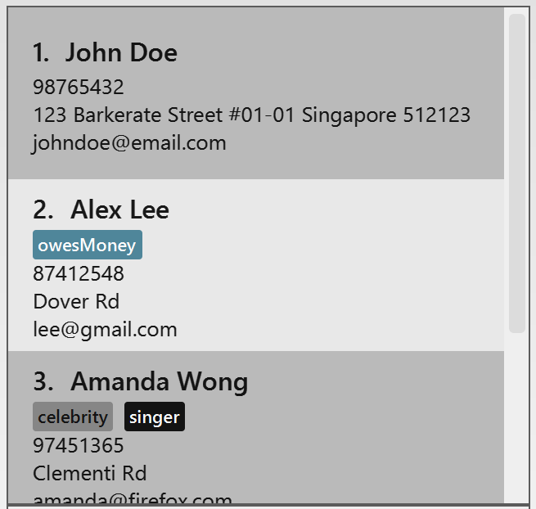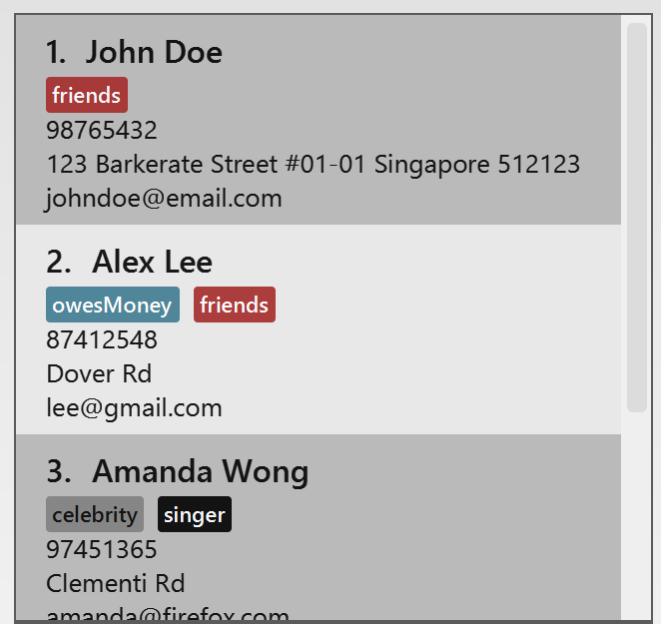

*Figure 12 State of PersonListPanel*

*after executing removeTag friends*

*Figure 11 State of PersonListPanel*

*before executing removeTag friends*

**3.2.8 Undoing previous commands:** undo

This command restores CelebManager to its previous state before the previous undoable command was executed.

Format: undo

Alias: u

* Undoable commands refer to the commands that modify CelebManager’s saved contact list, such as add, delete, edit, clear.
* Undoing celebrity deletion or celebrity tag removal through editing will not undo the changes made to the celebrity’s calendar. A new calendar will be created for the restored celebrity instead.

Example:

* delete 1

list

undo

This restores CelebManager to the state before executing delete 1.

**3.2.9 Redoing undone command:** redo

**This command can result in loss of information stored in CelebManager. Please double-check before executing it.**

This command reverses the most recent undo command.

Format: redo

Alias: r

Example:

* delete 1

undo

redo

This restores CelebManager to the state after executing delete 1.

**3.3 Appointment Commands**

This section details information on the commands for managing appointments in CelebManager. These commands allow you to modify the appointments stored in CelebManager but note that they are all **NOT undoable**.

**3.3.1 Adding appointment:** addAppointment

This command adds an appointment to CelebManager.

Format: addAppointment n/APPOINTMENT_NAME [l/LOCATION] [sd/START_DATE] [st/START_TIME] [ed/END_DATE] [et/END_TIME] [c/CELEBRITY_INDEX]… [p/POINT_OF_CONTACT_INDEX]…

Alias: aa

* START_DATE and END_DATE should be in the format dd-mm-yyyy.

e.g. 3rd July 2018 should be 03-07-2018.

* START_TIME and END_TIME should be in the format hh:mm.

e.g. 2.05pm should be 14:05.

* START_TIME must be at least 15 minutes before END_TIME.
* CELEBRITY_INDEX should refer to a contact with celebrity tag.
* POINT_OF_CONTACT_INDEX should refer to a contact without celebrity tag.

Example:

* addAppointment n/Concert sd/14-04-2018 st/14:00 ed/14-04-2018 et/16:00 c/1

This adds an appointment with the information provided and associates this appointment with the first celebrity in PersonListPanel.

Suppose CelebManager has two celebrities, Jay Chou and Taylor Swift. It should look like *Figure 13* below before executing the command.

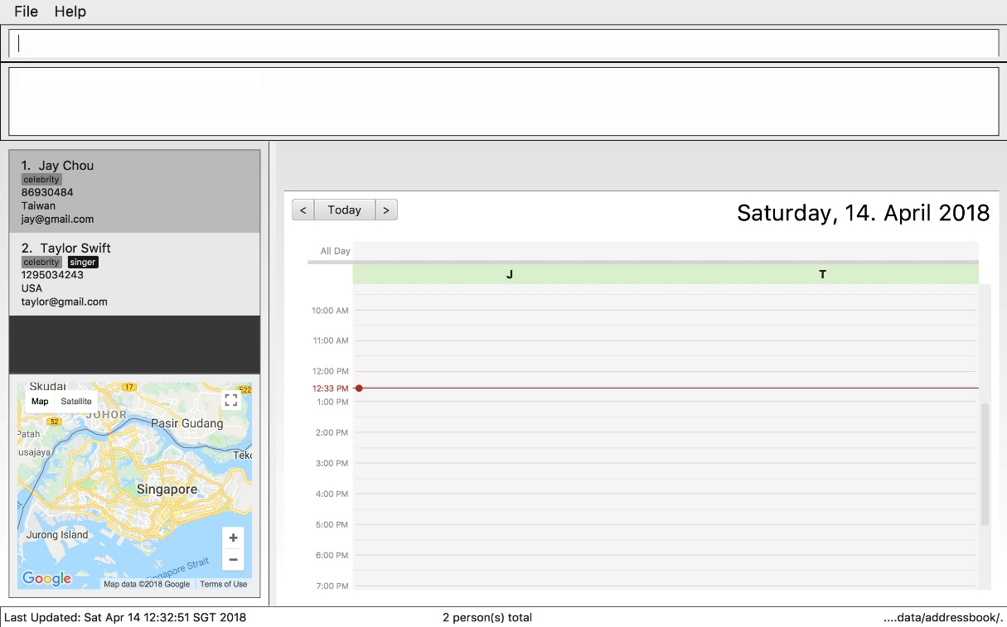

*Figure 13 State of CelebManager before executing addAppointment n/Concert sd/14-04-2018 st/14:00 ed/14-04-2018 et/16:00 c/1*

As the first celebrity is Jay Chou, the appointment gets added to Jay Chou’s calendar and updates CelebManager to *Figure 14* below.

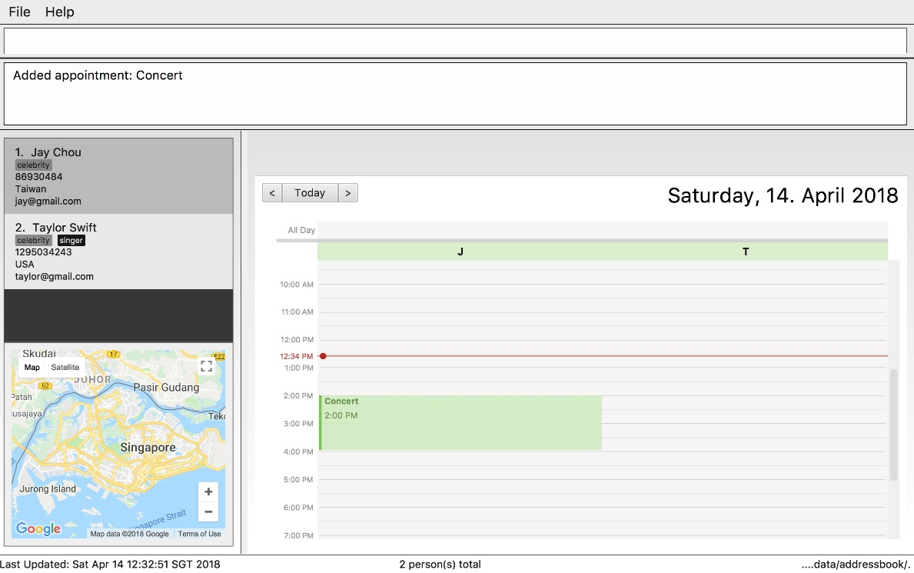

*Figure 14 State of CelebManager after executing addAppointment n/Concert sd/14-04-2018 st/14:00 ed/14-04-2018 et/16:00 c/1*

**3.3.2 Listing all appointments:** listAppointment

This command lists all the appointments.

Format: listAppointment

Alias: la

The calendar inside CalendarPanel will be replaced by an appointment list.

Example:

* listAppointment

Suppose CalendarPanel displays a calendar similar to the one in *Figure 15* below.

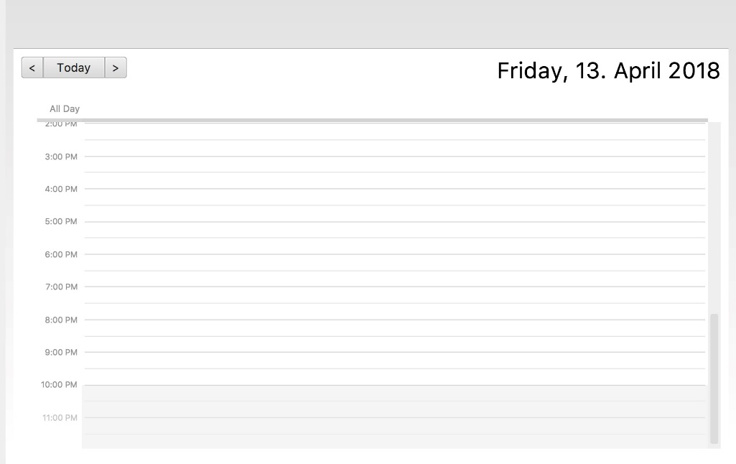

*Figure 15 State of CalendarPanel before executing listAppointment*

After executinglistAppointment, this calendar will be replaced by an appointment list as shown in *Figure 16* below.



*Figure 16 State of CalendarPanel after executing listAppointment*

**3.3.3 Editing appointment:** editAppointment

Pre-requisite: you can only edit an appointment when CalendarPanel is showing an appointment list.

This command edits the information of the appointment specified by the index in the current appointment list in CalendarPanel.

Format: editAppointment APPOINTMENT_INDEX [n/APPOINTMENT_NAME] [l/LOCATION] [sd/START_DATE] [st/START_TIME] [ed/END_DATE] [et/END_TIME] [c/CELEBRITY_INDEX]… [p/POINT_OF_CONTACT_INDEX]…

Alias: ea

* At least one of the optional fields must be provided.
* Existing values will be updated to the input values.
* START_TIME must be at least 15 minutes before END_TIME.

Example:

* editAppointment 2 n/Dentist Appointment l/Orchard Road p/3

This updates the second appointment in the appointment list with the information provided.

**3.3.4 Deleting appointment:** deleteAppointment

**This command can result in loss of information stored in CelebManager. Please double-check before executing it.**

Pre-requisite: you can only delete an appointment when CalendarPanel is showing an appointment list.

This command deletes the appointment specified by the index in the current appointment list in CalendarPanel.

Format: deleteAppointment INDEX

Alias: da

Example:

* deleteAppointment 1

This deletes the first appointment from the appointment list.

**3.3.5 Viewing appointment:** viewAppointment

Pre-requisite: you can only view an appointment when CalendarPanel is showing an appointment list.

This command provides a view of the appointment specified by the index in the current appointment list in CalendarPanel. ResultDisplay will show the details of the appointment and MapPanel will show the exact location of the appointment on Google Map.

Format: viewAppointment INDEX

Alias: va

Example:

* listAppointment

viewAppointment 1

This provides a view of the first appointment in the appointment list.

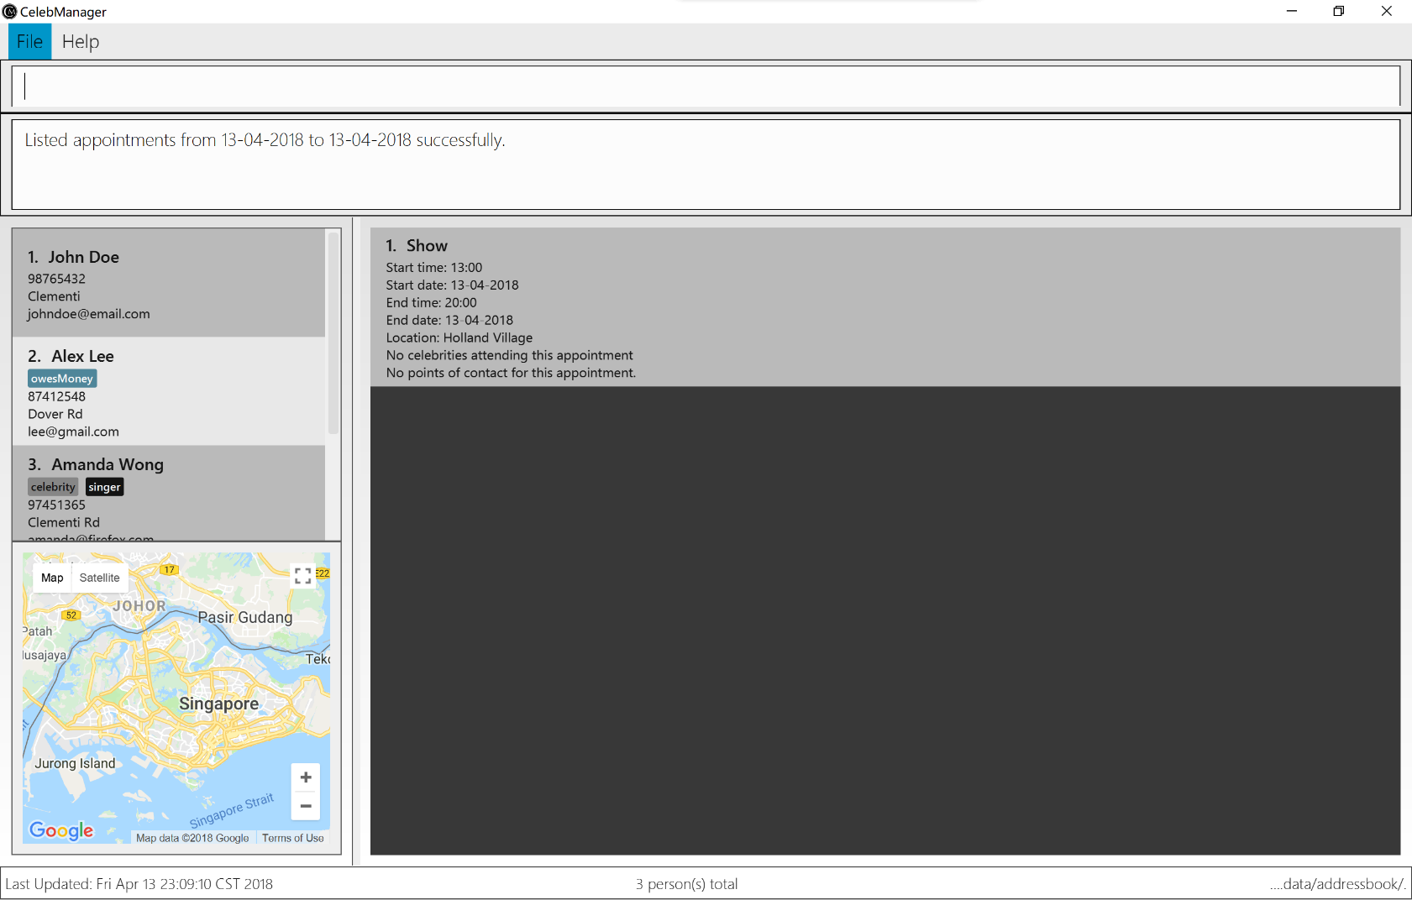Suppose the state of CelebManager is the same as shown in *Figure 17* below before executing viewAppointment 1.

*Figure 17 State of CelebManager before executing viewAppointment 1*

The first appointment is Show. Hence after executing viewAppointment 1, Show’s information is displayed in ResultDisplay and location is marked in MapPanel, as shown in *Figure 18*.



*Figure 18 State of CelebManager after executing viewAppointment 1*

**3.4 Calendar Commands**

This section details information on the commands to manage the calendars in CelebManager. These commands allow you to interact with the calendar in CalendarPanel.

In previous section on appointment commands, listAppointment is introduced to help you list out all appointments by replacing the calendar with an appointment list. To get the calendar back, you can use any of the commands mentioned in this section.

**3.4.1 Viewing celebrity’s calendar:** viewCalendar

This command changes the calendar displayed to the calendar of the contact specified by the index in the most recent contact listing in PersonListPanel.

Format: viewCalendar INDEX

Alias: vc

Example:

* viewCalendar 1

This displays the calendar of the first person in the most recent contact listing in PersonListPanel.

Suppose CelebManager looks like *Figure 19* below.

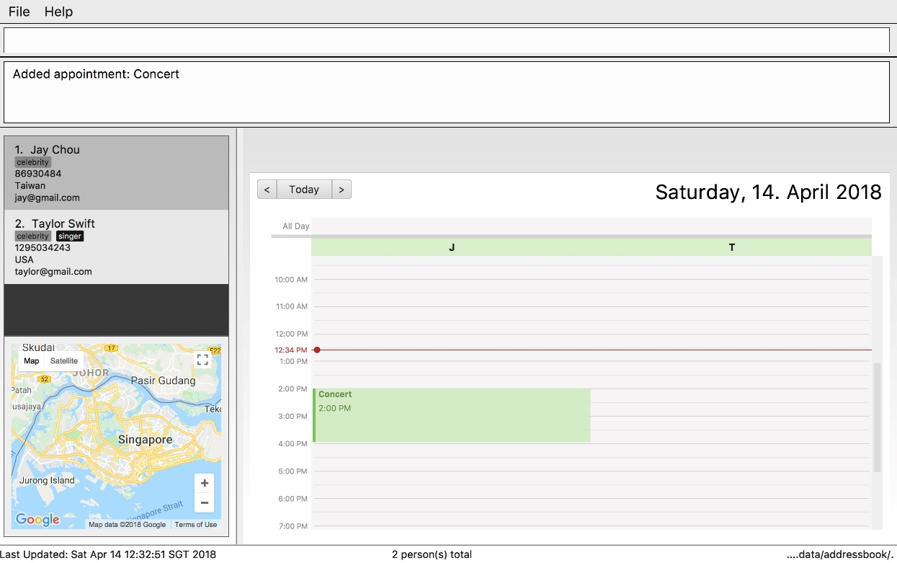

*Figure 19 State of CelebManager before executing viewCalendar 1*

Jay Chou is the first celebrity in PersonListPanel. Hence, his calendar gets shown after executing viewCalendar 1. CalendarPanel gets updated to *Figure 20* below.

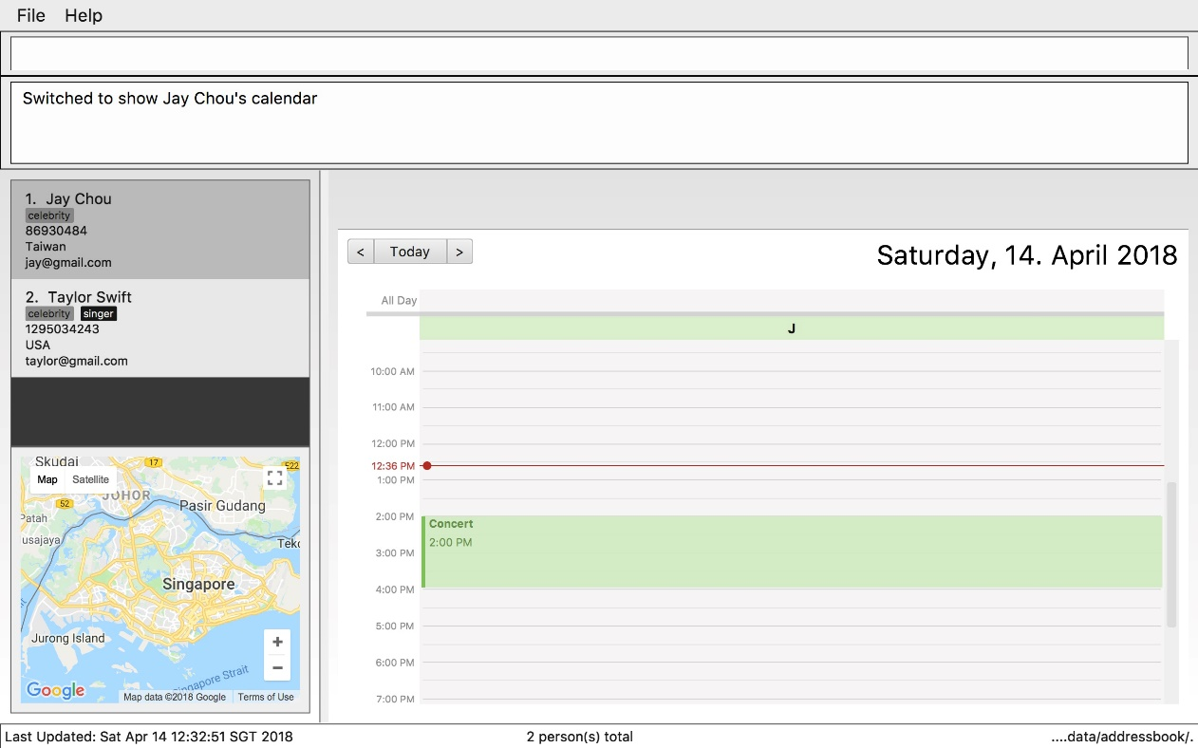

*Figure 20 State of CelebManager after executing viewCalendar 1*

**3.4.2 Viewing combined calendar:** viewCombinedCalendar

This command changes the calendar to a combined calendar that contains all celebrities’ appointments.

Format: viewCombinedCalendar

Alias: vcc

**3.4.3 Changing calendar view type:** viewCalendarBy

This command changes the calendar view to a different type: day, week, or month.

Format: viewCalendarBy VIEW

Alias: vcb

VIEW is not case-sensitive.

Examples:

* viewCalendarBy day

This displays a calendar that consists of a day’s appointments, as shown in *Figure 21*.

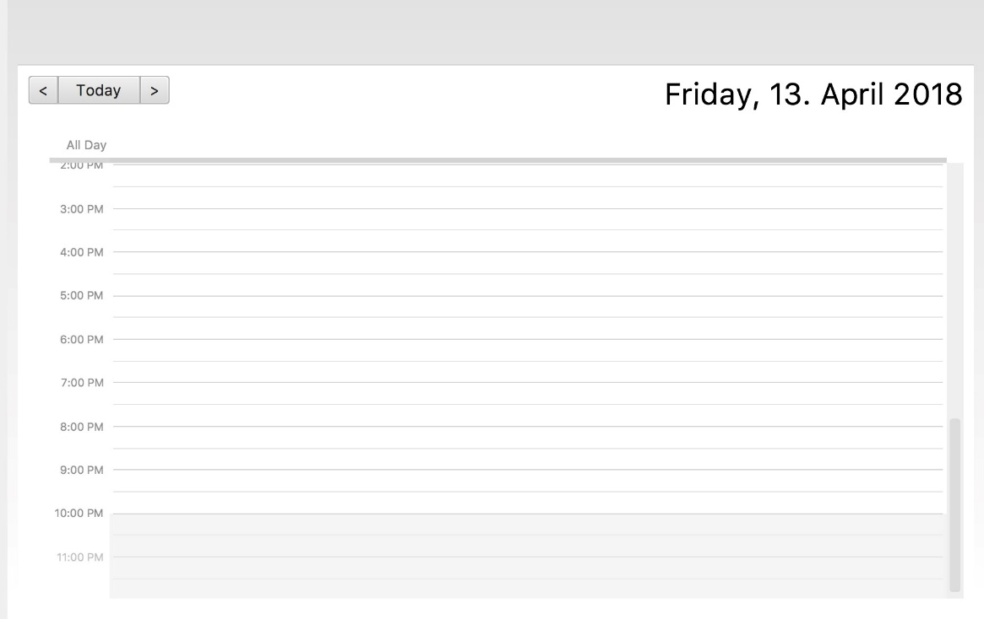

*Figure 21 State of CalendarPanel after executing viewCalendarBy day*

* viewCalendarBy week

This displays a calendar that consists of a week’s appointments, as shown in

*Figure 22*.

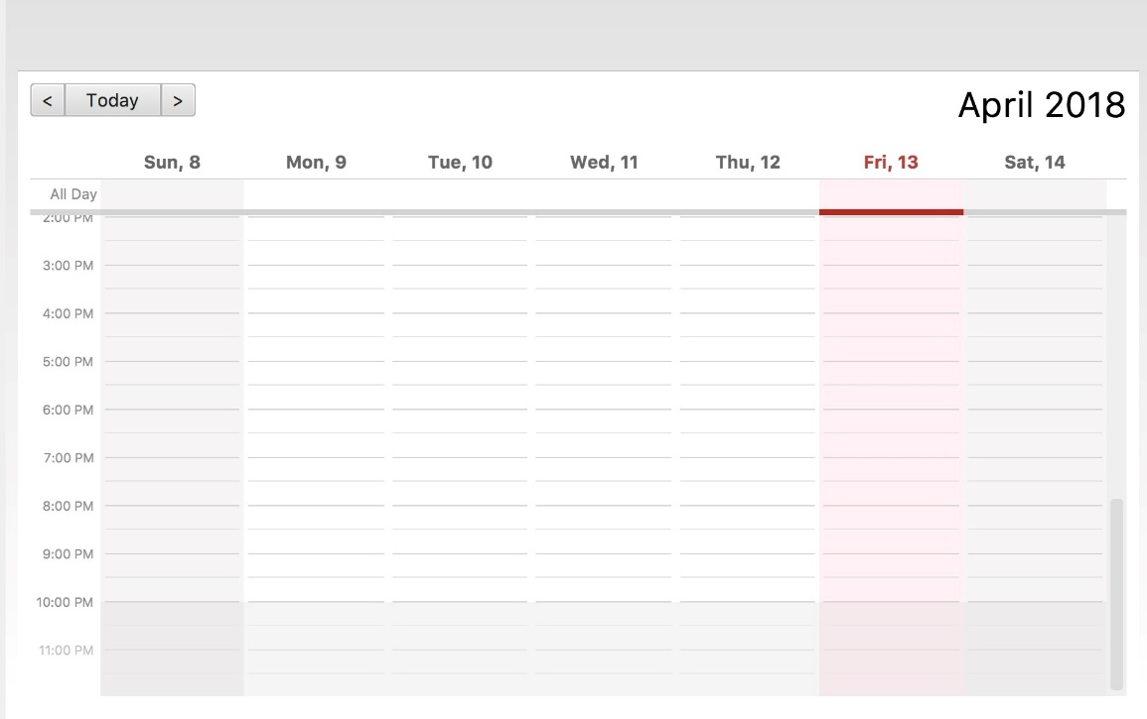

*Figure 22 State of CalendarPanel after executing viewCalendarBy week*

* viewCalendarBy month

This displays a calendar that consists of a month’s appointments, as shown in

*Figure 23*.

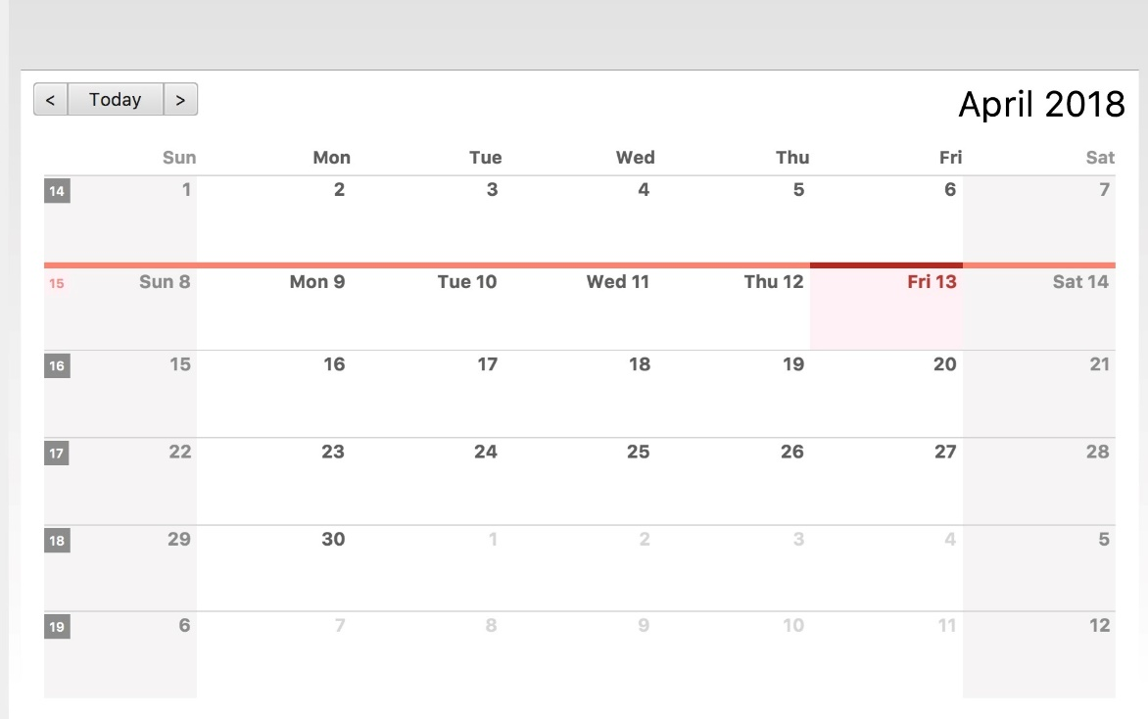

*Figure 23 State of CalendarPanel after executing viewCalendarBy month*

**3.4.4 Viewing specific date:** viewDate

This command displays a calendar of the specified day’s appointments.

Format: viewDate [DATE]

Alias: vd

* If DATE is omitted, CelebManager will take the current date.
* DATE should be in the format dd-mm-yyyy or dd-mm. For dd-mm, CelebManager will take the current year.

e.g. 3rd July 2018 should be 03-07-2018

* Changing the base date allows you to view the calendar for different weeks and months.

e.g. After executing viewDate 03-07-2018 command, executing viewCalendarBy week will show the calendar for the first week of July 2018, and executing viewCalendarBy month will show the calendar for July of 2018.

Examples:

* viewDate

This displays a calendar of the current day’s appointments.

* viewDate 2018-05-03

This displays a calendar of the appointments on 3rd May of 2018. The calendar displayed should look like the one shown in *Figure 24* below. The date on the top right corner should be the same as the date entered.

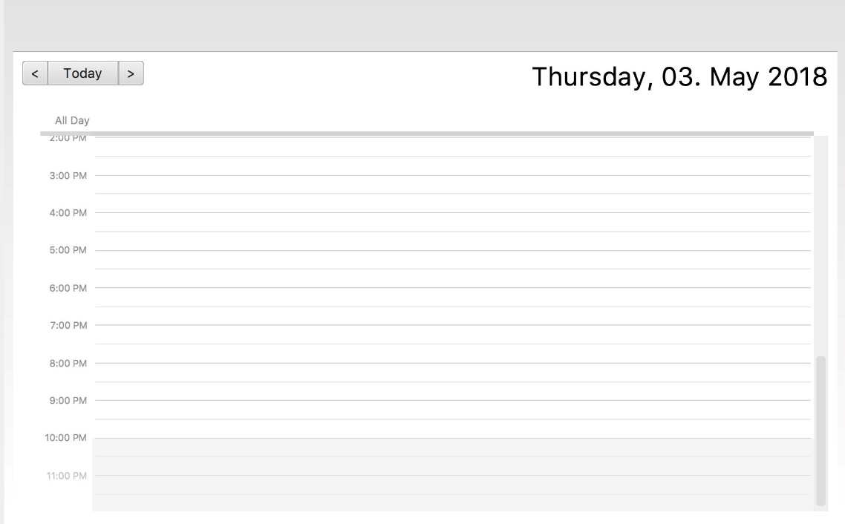

*Figure 24 State of CalendarPanel after executing viewDate 2018-05-03*

**3.5 Map Commands and Features**

This section details information on the commands and features for map in CelebManager. These commands and features allow you to interact with the map in MapPanel.

**3.5.1 Clicking buttons on map:**

There are three ways in which you can use mouse click to interact with MapPanel.

* You can click on the Map or Satellite button to toggle between road map view or satellite view.
* You can click the + or – button to zoom in and out of the map respectively.
* You can click, hold and move the mouse cursor to shift the current view of the map.

**3.5.2 Showing location on map:** showLocation

This command shows the specific location in the map. Any existing location marker or route will be removed.

Format: showLocation ma/ADDRESS

Alias: sl

* ADDRESS should be a postal code, road name, location name or building name.
* Any existing route or location marker will be removed after executing a showLocation command.

Example:

* showLocation ma/Punggol

This re-centers MapPanel to the new location marker on Punggol.

Initially, MapPanel should look like *Figure 25* on the left below. After executing showLocation ma/Punggol, MapPanel should look like *Figure 26* on the right below.



*Figure 25 State of MapPanel before*

*executing showLocation ma/Punggol*

*Figure 26 State of MapPanel after*

*executing showLocation ma/Punggol*

**3.5.3 Estimating routes on map:** estimateRoute

This command estimates the route to travel from one address to another in MapPanel and displays the estimated distance and time of travel in ResultDisplay.

Format: estimateRound sma/START_ADDRESS ema/END_ADDRESS

Alias: er

* START_ADDRESS and END_ADDRESS should be postal codes, road names, location names or building names.
* Any existing route or location marker will be removed after executing an estimateRoute command.

Example:

* estimateRoute sma/Punggol ema/NUS

This re-centers MapPanel to the route from Punggol (marked as A) to NUS (marked as B).

Initially, MapPanel should look like *Figure 27* on the left below. After executing estimateRoute sma/Punggol ema/NUS, MapPanel should look like *Figure 28* on the right below.



*Figure 28 State of MapPanel after*

*executing* estimateRoute sma/Punggol ema/NUS

*Figure 27 State of MapPanel before*

*executing* estimateRoute sma/Punggol ema/NUS

**4 Frequently Asked Questions**

**Question:** How do I transfer my data to another computer?

**Answer:** Install the app in the other computer and overwrite the empty data file it creates with the file that contains the data of your previous CelebManager folder.

**Question:** What if there is an error message after entering a command?

**Answer:** Please ensure that you adhere to the command format stated in this User Guide, and ensure that you are not accessing the wrong pointer.

**5 Command Summary**

The following is the summary of all the commands introduced in **Section 3: Commands** displayed in alphabetical order. The commands are displayed with their respective command format and an example highlighting the usage if the command has parameters.

|  |  |  |
| --- | --- | --- |
| Command  Keyword | Format | Example |
| add | add  n/NAME  p/PHONE_NUMBER  e/EMAIL  a/ADDRESS  [t/TAG]… | add  n/James Ho  p/22224444 e/jamesho@example.com a/Clementi Rd  t/friend  t/colleague |
| addAppointment | addAppointment n/APPOINTMENT_NAME [l/LOCATION] [sd/START_DATE] [st/START_TIME] [ed/END_DATE]  [et/END_TIME] | add  n/Oscars 2018 l/Hollywood sd/23/03/2018  st/14:00  ed/23/03/2018  et/20:00 |
| clear | clear |  |
| delete | delete INDEX | delete 3 |
| deleteAppointment | deleteAppointment INDEX | deleteAppointment 1 |
| edit | edit INDEX  [n/NAME]  [p/PHONE_NUMBER]  [e/EMAIL]  [a/ADDRESS]  [t/TAG]…​ | edit 2  n/James Lee e/jameslee@example.com |
| editAppointment | editAppointment INDEX [n/APPOINTMENT_NAME] [l/LOCATION] [sd/START_DATE] [st/START_TIME] [ed/END_DATE]  [et/END_TIME] [c/CELEBRITY_INDEX]…​ [p/POINT_OF_CONTACT_INDEX]… | editAppointment 1  n/Dentist Appointment l/Clementi Road st/15:00  et/16:00  c/3 |
| estimateRoute | estimateRoute  sma/LOCATION  ema/LOCATION | estimateRoute sma/Punggol  ema/NUS |

|  |  |  |
| --- | --- | --- |
| Command  Keyword | Format | Example |
| find | find KEYWORD [MORE_KEYWORDS] | find James Jake |
| help | help |  |
| history | history |  |
| list | list |  |
| listAppointment | listAppointment  [START_DATE END_DATE] | listAppointment  04-05-2018 05-05-2018 |
| redo | redo |  |
| removeTag | removeTag TAG | removeTag friends |
| select | select INDEX | select 2 |
| showLocation | showLocation  ma/LOCATION | showLocation ma/Prinsep Street |
| undo | undo |  |
| viewAppointment | viewAppointment INDEX | viewAppointment 1 |
| viewCalendar | viewCalendar INDEX | viewCalendar 1 |
| viewCalendarBy | viewCalendarBy VIEW | viewCalendarBy week |
| viewCombinedCalendar | viewCombinedCalendar |  |
| viewDate | viewDate [DATE] | viewDate 2018-05-03 |